### Saker att tänka på: User interface design and overall game design

GRAPHIC DESIGN IS VISUAL COMMUNICATION

*Puzzle games*: All info ska finnas synlig, och klar att användas för att lösa pusslet

Tell the player anything you need to know to solve the level, give them all the tools, let them figure out how to use them

Game idea: Visually indicate at what point you would take falling damage

**VISUAL HIERARCHY:** Arrange after importance and scale/colour accordingly

Everything should be easy to find, but clearly prioritised

**Menu:** Organisation and navigation has to be consistent and on point

Don't make the player ask or wonder “Where could this be?” or “Why is this there?”

**UI in game:** Give the player subtle but clear info

*Diegetic UI*- UI that is built in to the gaming itself

Eg - Deadspace, character equipment is all the info the player needs

Contrasting colours deliver info

UI should not obstruct, hinder, confuse or steal attention from the gameplay

UI theme can/should have a clear inspiration

Game idea: Font is aligned with the steampunk theme

**UI - Meny**

Play

* Continue
* Level select

Settings (?)

Exit

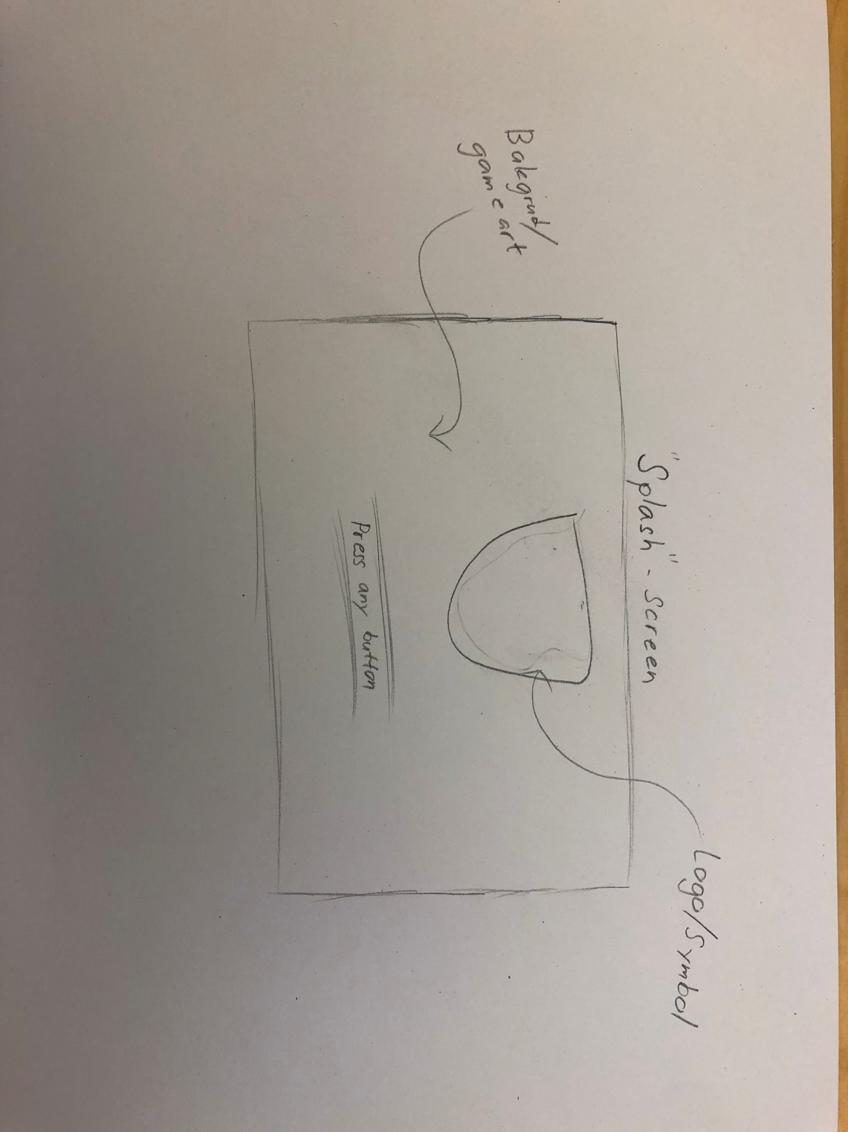

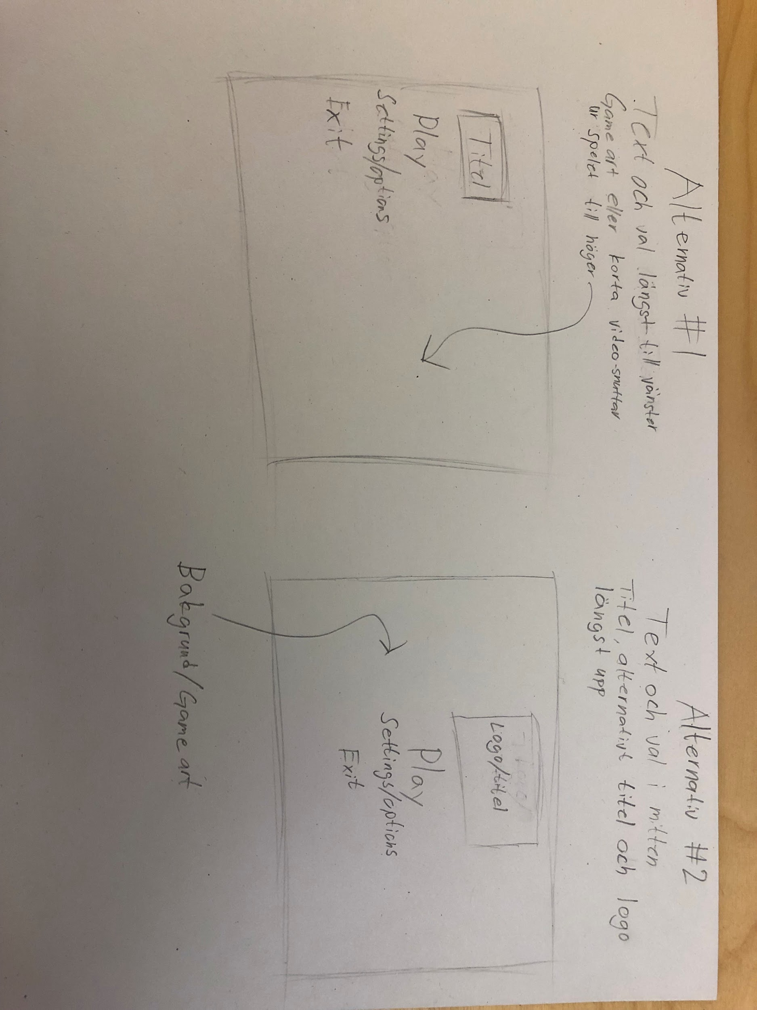

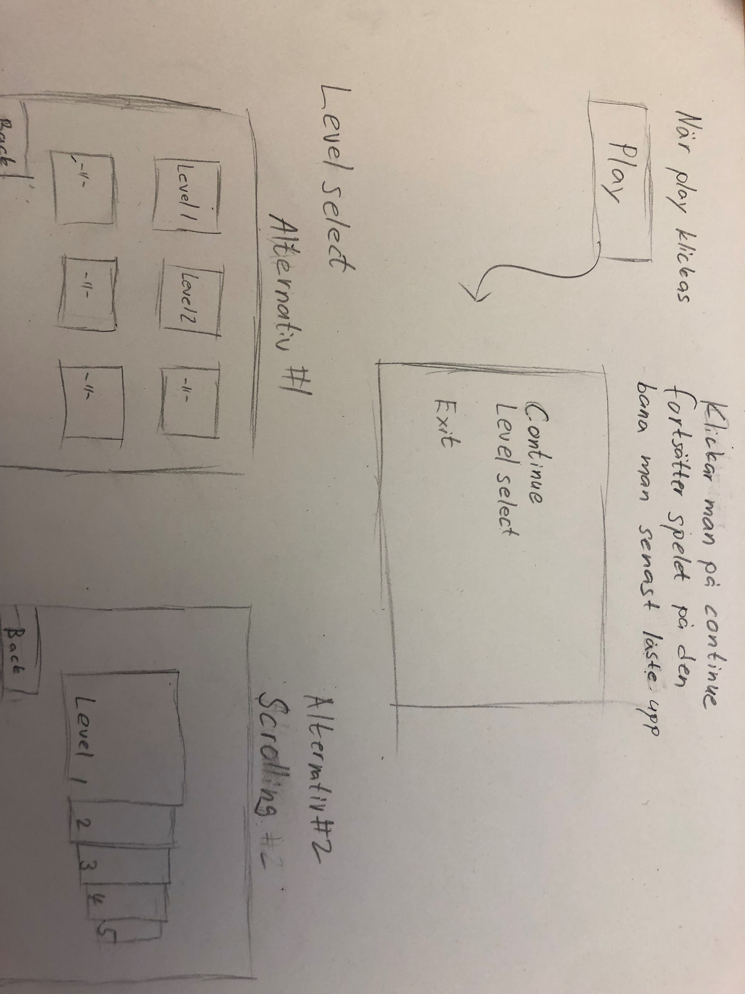

**In-game UI**

In-game UI kommer vara väldigt minimal ifall det ens ska finnas någon.